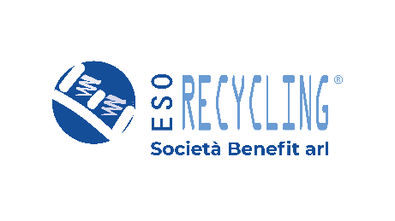



Launch of End-of-Life Sports Equipment Collection with esosport in 23 Municipalities of the Province of Macerata
An initiative promoted by ATA 3 – Macerata and COSMARI SRL
January 29, 2026 – The presence of esosport across Italy continues to grow thanks to the agreement with ATA 3 – Macerata and COSMARI SRL, which have chosen to launch a project dedicated to the collection and recycling of end-of-life sports equipment in 23 municipalities in the province.
esosport, a brand of ESO RECYCLING, a company specialized in the treatment of sports waste and waste from the fashion and work sectors, was founded in 2009 with the aim of reducing the disposal of sports materials in landfills and promoting awareness that recycling is not only possible, but can also generate new secondary raw materials. These materials can be used in the production of sports flooring, playground surfaces, and sports-related products.
The initiative was presented on Thursday, January 29 at 11:00 AM at the Auditorium of the ITAS “Matteo Ricci” School in Macerata, which is participating in the project, in the presence of: Rita Emiliozzi, Principal of ITAS Matteo Ricci; Sandro Parcaroli, President of the Province of Macerata; Massimo Principi, Director of ATA 3 – Macerata; Paolo Gattafoni, President of COSMARI SRL; Brigitte Pellei, Director of COSMARI SRL; Nicolas Meletiou, Managing Director of ESO RECYCLING Società Benefit; and several school classes.
The initiative involves 23 municipalities in the Province of Macerata, 46 schools, 11 bicycle shops and an equal number of tennis clubs, as well as 3 sports facilities, for a total of 71 collection points across the territory for worn-out sports shoes, bicycle inner tubes and tires, and used tennis and padel balls.
The project will last two years and includes the placement of ESObox containers at agreed locations, dedicated to the collection of materials and available to citizens who choose recycling for their old sports equipment. ESO RECYCLING will be responsible for emptying the containers and managing the recycling process at its facility in Tolentino.
“An initiative fully embraced by our school community. Our students, also thanks to the work of their teachers, are very receptive to everything related to the environment and the circular economy. A very interesting project that allows materials that would otherwise end up in landfills to be recovered,” said Rita Emiliozzi, Principal of ITAS Matteo Ricci, at the opening of the press conference.
“ATA plans services in synergy with Cosmari across the territory, and this innovative project allows us to collect specific types of waste which, through a virtuous cycle, are transformed into secondary raw materials and reused in another production phase for their full recovery,” stated Massimo Principi, Director of ATA 3 Macerata.
“We are pleased to welcome this agreement, which expands esosport in the Province of Macerata, a territory that is particularly important to us and where our ESO RECYCLING plant in Tolentino is located. It is an important signal that strengthens our connection with the territory and confirms the value of a shared path built together with the local community,” declared Nicolas Meletiou, Managing Director of ESO RECYCLING.
“This morning at ITAS Matteo Ricci in Macerata, in the presence of students, we presented, together with ATA 3 Macerata and ESO RECYCLING, a very interesting project, sharing part of the Macerata area with a private company that has the same mission as ours: creating secondary raw materials by transforming specific sports-related waste into shock-absorbing flooring for playgrounds or sports surfaces. What truly matters to us is promoting a message about protecting the environment from waste production, which must necessarily be properly sorted—an increasingly pressing issue in public debate,” emphasized Paolo Gattafoni, President of COSMARI SRL.
“A concrete project that involves younger generations and makes them key players both at school and in the places where they practice sports, such as tennis clubs. We are highly motivated to actively participate and contribute to the recovery of bicycle tires, sports shoes, and tennis and padel balls, which will be transformed into new reusable materials, fully embodying the principles of the circular economy,” recalled Brigitte Pellei, General Director of COSMARI SRL.

